Objet SOP

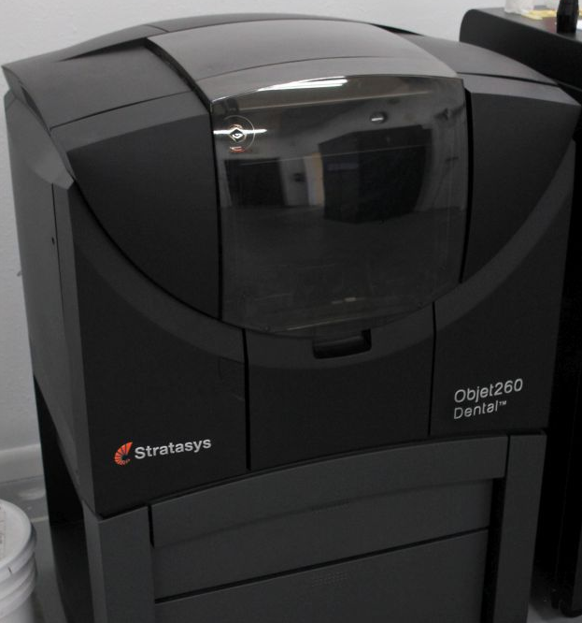

This SOP is meant only for those who have been previously trained by proficient members of TSD’s CAM team. The Objet is a very expensive (>$100,000 when first introduced) and sophisticated piece of equipment that should not be utilized by an inexperienced operator.

The Objet does not have direct network access and is connected to another PC via an A B switch. (Note: Since the premature demise of the original networked PC, a new PC with the nesting software was setup without network access. Now all stl files must be transferred via thumb drive.)

\*Daily maintenance must be run on Objet prior to use. If you are not trained in maintenance, you are not trained in operation of this printer\*

Step 1. Choose and load necessary stl files from the dental model directory onto a thumb drive for transfer to the objet environment. [see pic]

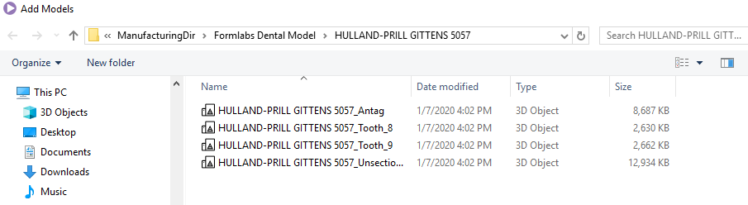

\*Solid = unsectioned (sic) model – Full & Quad = all files – always print all dies\*

Step 2. Transfer said files to Nesting PC connected to Objet (be sure the A/B switch in the correct position to see the Nesting PC’s screen [see pic].

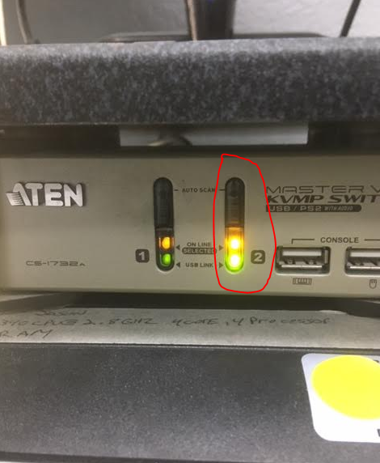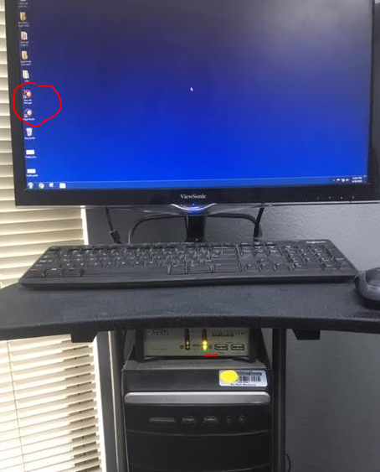

You should see the nesting software icon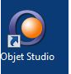 on the desktop. [see pic]

Step 3. Double click the “Objet Prints (Use me !!!!)” folder 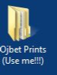on the desktop. [see pic]

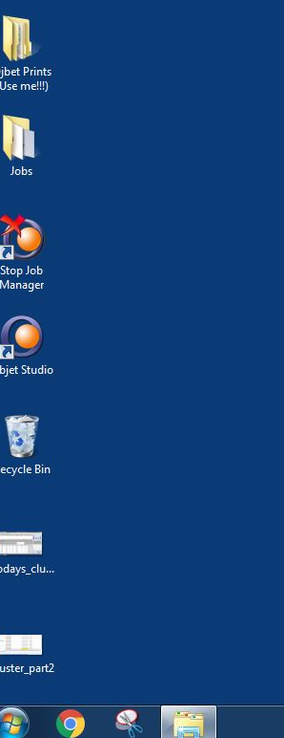

Step 4. Choose the correct month. If your current month isn’t listed, please create the month’s folder. [see pic]

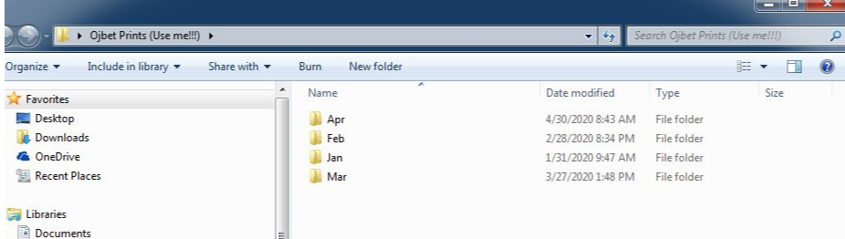

Step 5. In the month folder, create the folder to hold the run’s models via the naming convention mm-dd-Tray-number of run that date. [ see pic]

(example: Second run on 04/30 would be 04-30-Tray-2 as the folder name.)

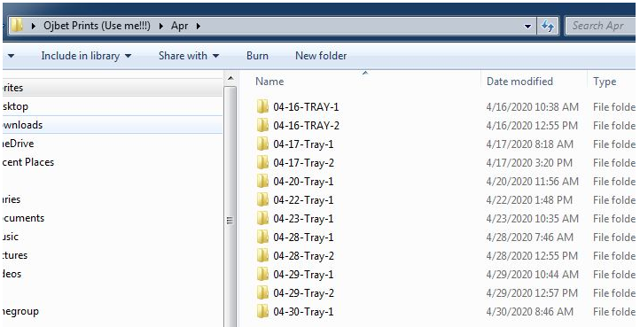

Step 6. Paste the stl files to be printed from the thumb drive to the run folder created. [see pic]

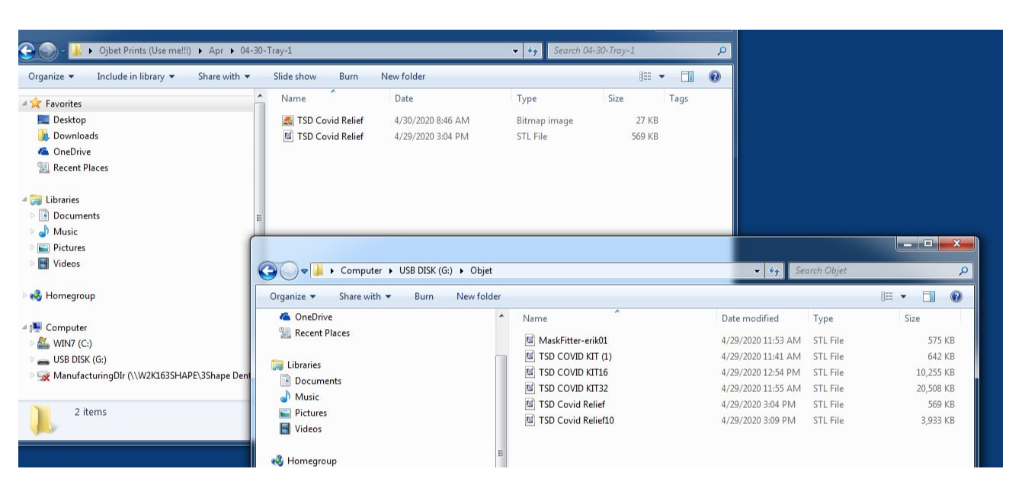

Step 7. You are expected to nest the files per the Objet users guide chapter 5 attached to the Objet in the Equipment Trello board. This is part of Fab Print Room training. Below is a condensed version for previously trained personnel who require guidance.

Double Click the objet studio icon to start the nesting software. [see pic]



Here are the parts of the objet studio per the users manual. [see pic]

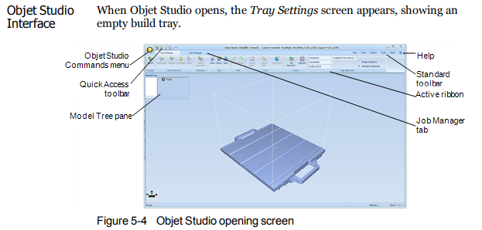

Step 8. Click the insert button in the top left corner. [ see pic] 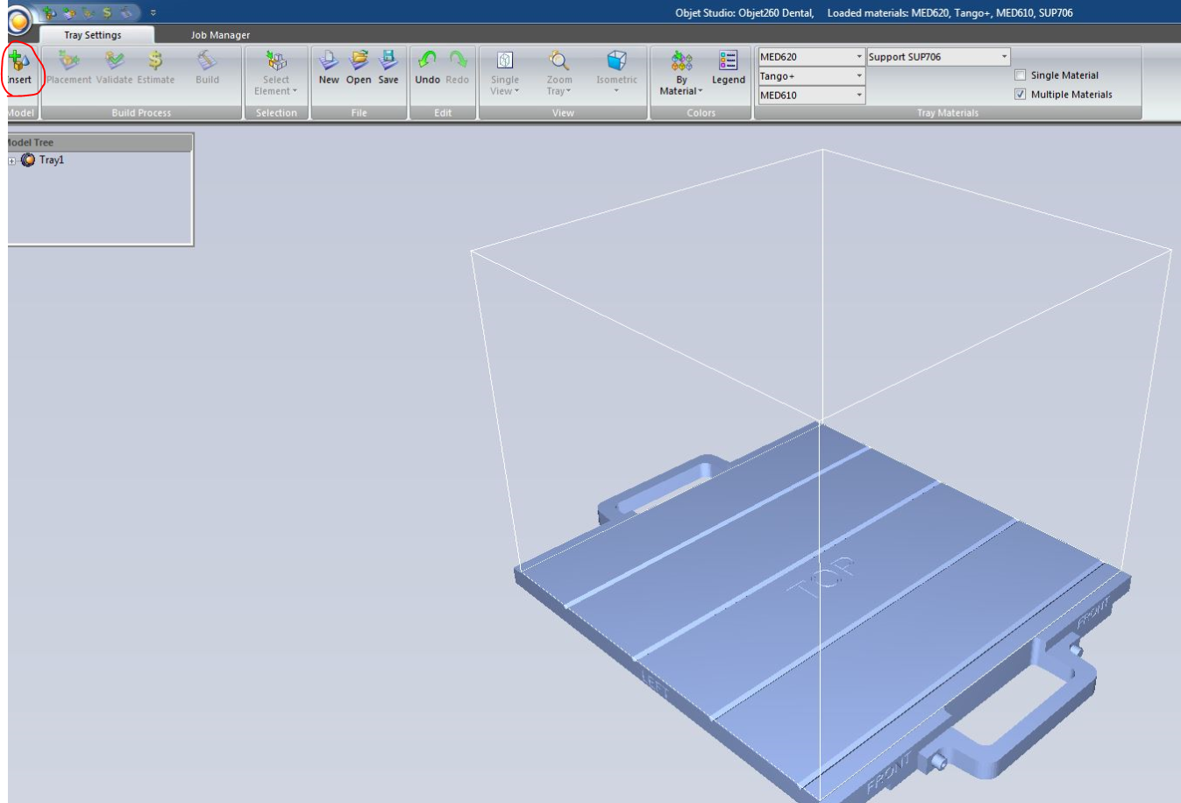

Step 9. Choose the run folder previously created and click on the stl files you want in the print run. Then click the insert button. [ see pic ]

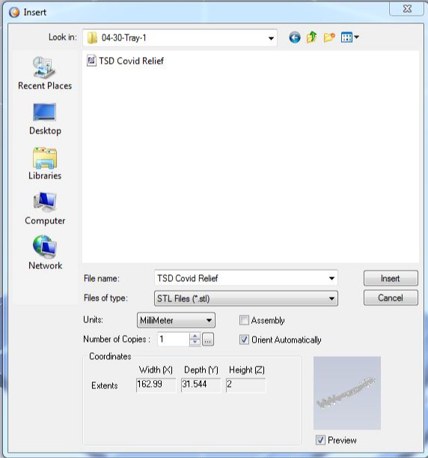

The models will appear on the build tray in a bluish green highlight. [see pic] 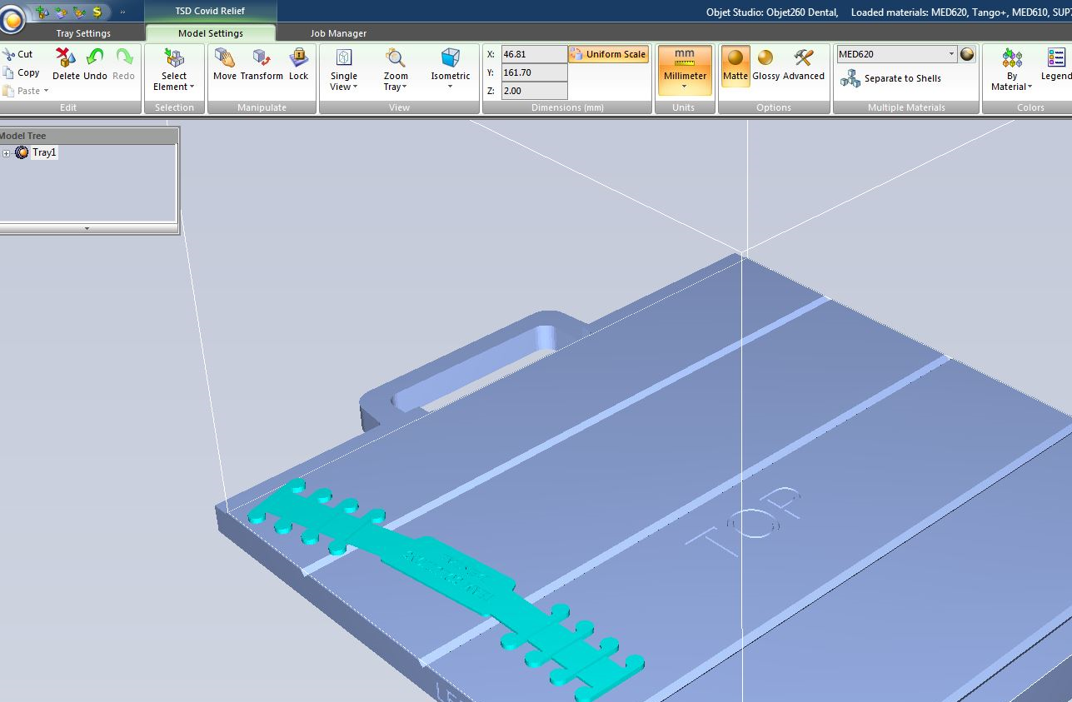

Step 10. Select the material you’d like to use for the run via the drop down box or by left clicking on each model to select the material individually. [see pic]

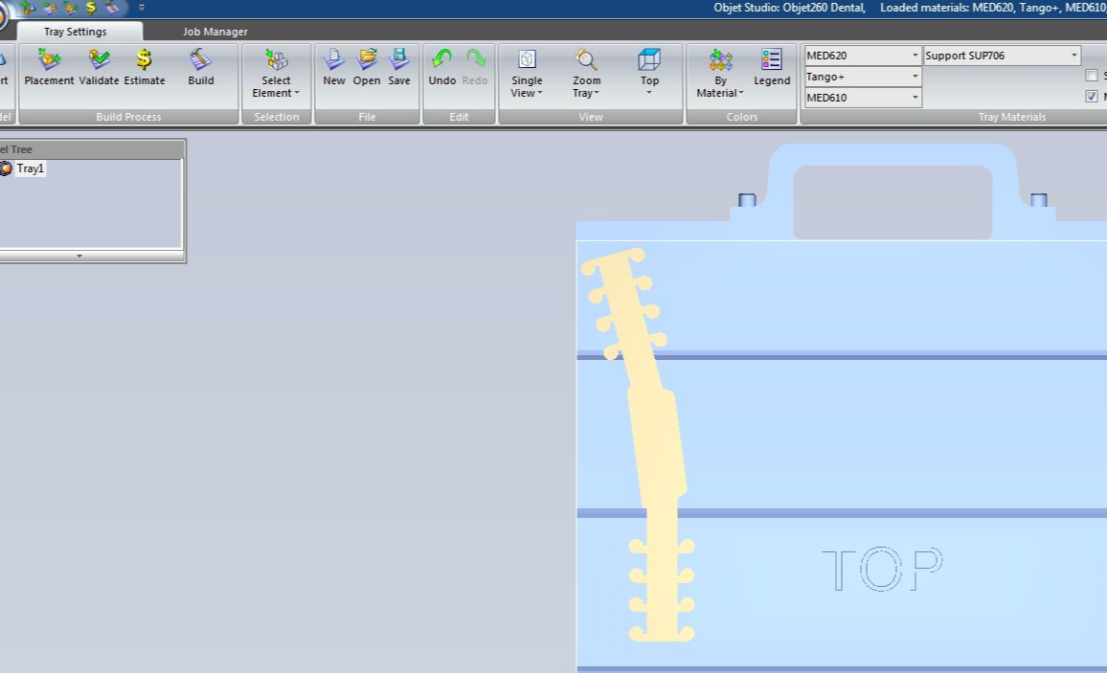

Step 11. Once all the models have been inserted onto the build tray, click the “Placement” button in the upper left corner. This will automatically move all models to ideal positions for printing on the objet. [see pic]

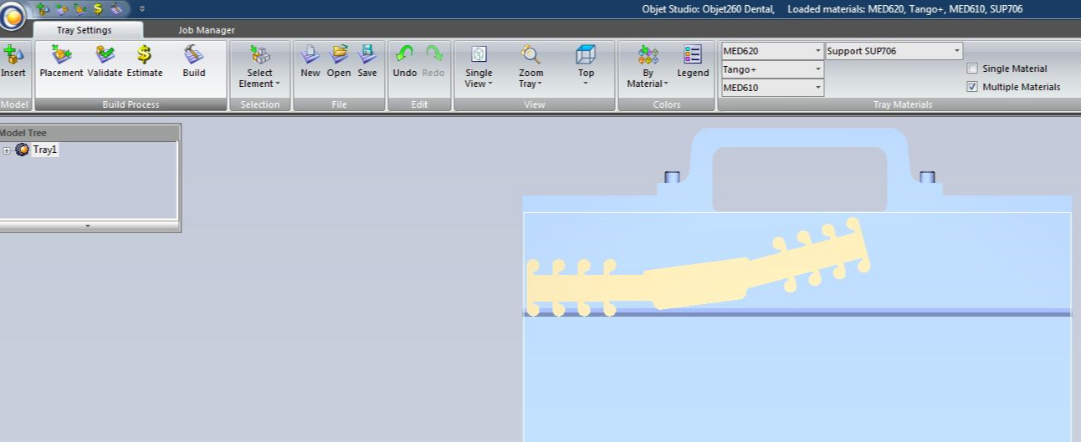

Step 12. Click the “Build” button in the upper left corner. A popup will show you how long each kind of print mode will take. Just hit “next” unless you are trained in switching modes and instructed to do so. [see pic]

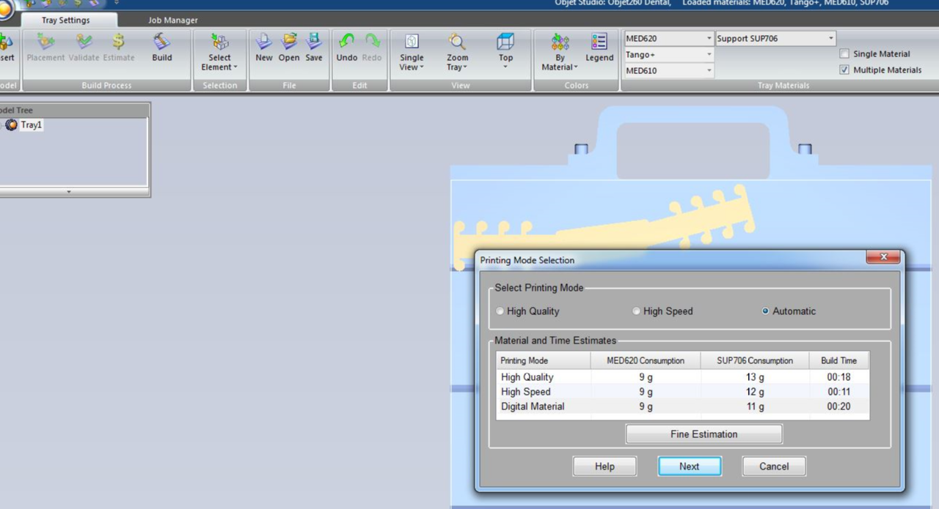

Step 13. Another popup will appear asking for a folder to place companion files for printing. Enter the same name of the run folder you created and hit “save”.

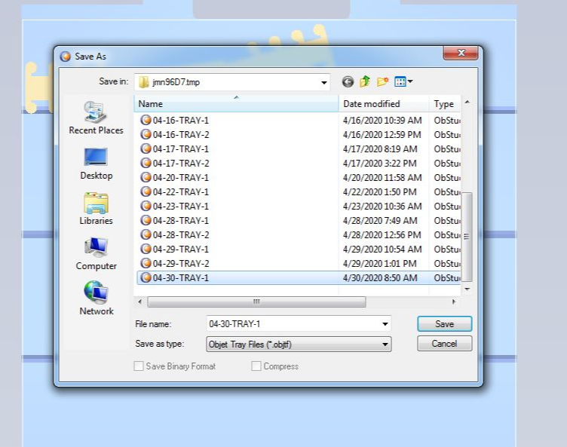

Step 14. The tray setting screen will close and the job manager screen will open. Your run will load and the green status bar will increment across the screen. [see pic]

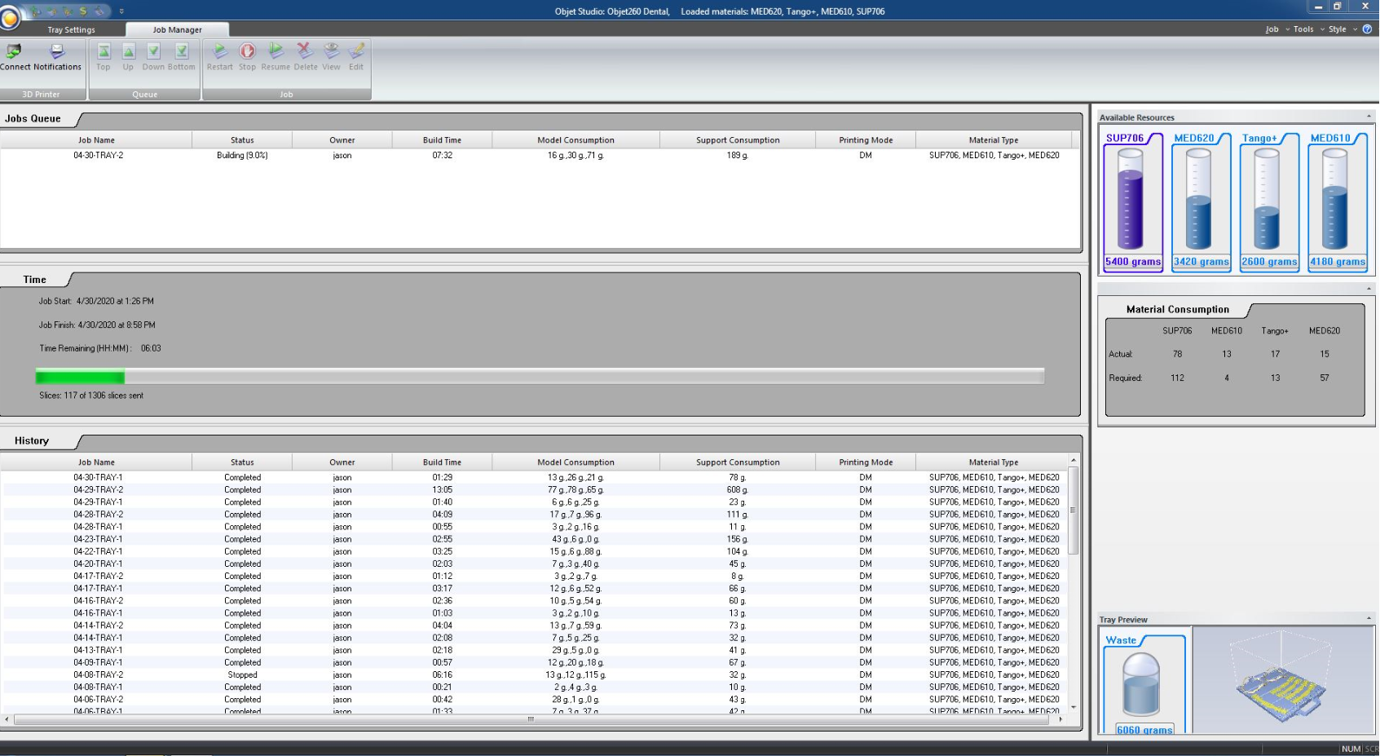

Step 15. On the objet printer itself, check to be sure the tray is in the upright position. Check the UV temperature labels to verify fans are operational per your training. Check for the overall Objet function prior to starting the job. [se pic]

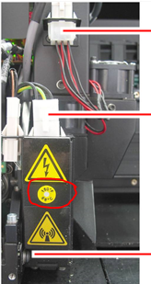

Step 16. Start the job on nesting PC. Switch to Objet onboard PC to start the job on the Objet. You’ll see the printer interface no the screen and you must click the “online” button that looks like a red record button. [see pic]



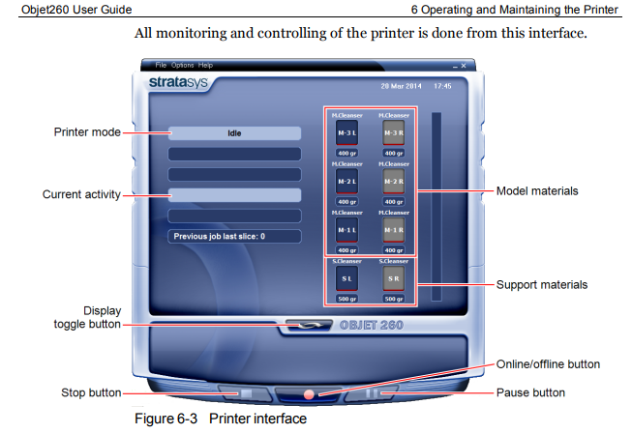

It will turn green and the screen will look like this. [see pic]

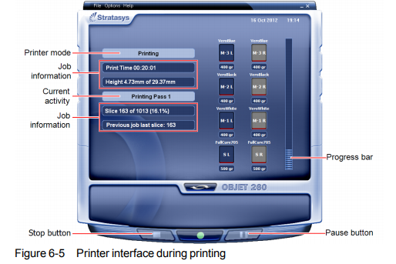

Step 17. Upon completion of the print run, remove the build +

tray to scrape parts (except for dies and soft tissue) into power washer.

Step 18. Thoroughly clean parts with power washer. Remove and inspect. Rinse and repeat until completely clean. Wash dies and soft tissue by hand. Verify fit of all parts prior to moving them on to next step. All dies and soft tissue go in a baggy marked with the case number per supervision. [see pic]

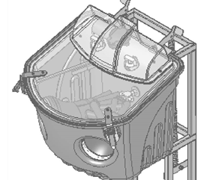

If you have questions about anything, stop and ask. Verify proper fit, cleanliness, and final quality of the models prior to allowing any of them to leave the CAM area. All dies go in small baggies with the case number written on the bag.

Objet 3D Printer SOP